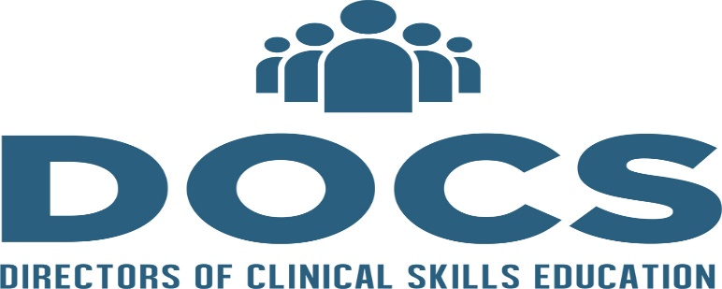

In This Issue
President and President-Elect Message  Annual Meeting Update  Listserv  Membership | Silvestri Grant Application Now Open  Join DOCS Slack Channel  DOCS Admin Recruitment  Upcoming Webinars

Presidents Message

ge
by Todd Cassese

By: Katharine (Katie) Yamulla (President) and Christine (Steen) Tsai (President Elect)
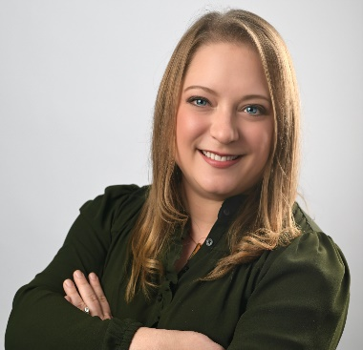
Happy New Year fellow DOCS friends! It is hard to believe that it is already 2026! Feels like we just saw many of you at our Annual Meeting in November! Joanne- thank you for a wonderful year of being our previous President!

DOCS is officially entering its 15th year, and there is a lot of exciting momentum ushering in this anniversary year! The new listserv is helping everyone connect again! Submissions are open for the Ron Silvestri grant through February 1st, which has grown to a 6,000 opportunity. (Up from the previous amount of $3,000!) We will be introducing a DOCS Slack Channel for additional ways to collaborate; The program planning committee will soon announce our 2026 virtual line-up of webinars; We will be recruiting a part-time admin to help maintain our website, manage the listserv monitor the DOCS gmail account and navigate membership payments/receipts; The Regional Reps are also working on something exciting- more to come on that!
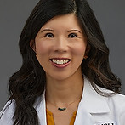
Speaking of the Annual Meeting, thank you to our Program Planning Committee for organizing such a fantastic event! From delivering a dynamic Plenary, developing innovative workshops, cultivating successful posters, and hosting our first-ever DOCS-sponsored Happy Hour- what a day it was! Everyone who attended stayed for the Happy Hour to continue networking, noshing on appetizers, sipping fun drinks, and jamming out to Deepu’s DJ talent! We had such a wonderful time connecting with new friends and reconnecting with old. There was so much creative energy, and we are grateful for the chance to be together. We hope you will join us for this year’s meeting in Anaheim, CA, on November 6th.

As we mentioned in the last newsletter, we no longer have an active technology committee. If anyone is interested in rekindling that committee, please let us know! On a related note, if you know anyone who would be interested in the part-time admin position, please email the DOCS Gmail account and Katie at katharine_yamulla@nymc.edu. It will be a paid, per diem position.

Wishing you all the best,
Katie and Christine

Ron Sylvestri Grant Application

2025-2026 DOCS RS Grant Call for Proposals is now open! Submission deadline February 1, 2026.
Click here for the application form https://forms.gle/bbYCb9JsjPWss3tn8

Rationale and Purpose
Directors of Clinical Skills Education (DOCS) supports scholarship in clinical skills education. We are
excited to announce the second annual DOCS Ronald Silvestri Clinical Skills Education Grant will be
awarded in 2025. The award will be offered to support innovation in clinical skills education. We hope
to foster scholarship across the medical education community by encouraging collaboration across
institutions or medical disciplines.

Grant Details
DOCS will award one $6,000 research grant annually to be dispersed over a two-year period. The grant
recipient(s) will be announced and celebrated at the DOCS Annual Meeting in November. Awardees will
present their completed project at an annual DOCS Meeting at the conclusion of the grant period.

Eligibility
Medical educators affiliated with a (US) allopathic or osteopathic medical school are eligible to submit a
proposal. The Principal Investigator (PI) must be a member of DOCS. Trainees who would like to submit
a proposal must have a faculty member or medical educator as a co-Primary Investigator (co-PI).
Applicants may submit one proposal per year.

Once you are ready for submission, you must complete this form using the link above. If you have any questions, please get in touch with Candace Y Pau at candace.y1.pau@kp.org

Joining the DOCS Slack Channel

One thing we strive to do after a conference is to continue that sense of belonging, connection, and inspiration. Along that vein, We are piloting DOCS channel on the Slack App in order to facilitate continued conversations and relationships in a way that might be more conversational than the Listserv. The DOCS Listserv WILL still exist and have a role in our community, but think of the difference between when you want to text someone (i.e. - Slack them) vs when you want to email them (i.e. - Listserv message).

To join the DOCS Slack, please go to this link:
https://join.slack.com/t/docsdirectors-ibg1894/shared_invite/zt-3hi0hdtlt-lLNV1kxyUZOCXwpYleTd3A

Many of us use Slack already in our work/community organizations, but for those who don’t (yet!), what we love about it is that you can easily see everyone’s name and DM them as well as start additional channels that look more organized than it does in WhatsApp communities (our other contender).

Hope you all are doing as well as can be in these times where, as former U.S. Surgeon General, Vivek Murthy said at the AAMC LSL 2025 Opening Plenary, the ground is constantly shifting from under us. We remain grateful for your engagement in the DOCS community and hope to connect with you soon.

Also, for those of you who don’t have the bandwidth to join Slack now.. we will send this message again in February!

Joining the DOCS Listserv

Hopefully, you are getting this because you are already registered to our listserv, but feel free to share with other members of your institutional networks.

It sometimes takes about 5 minutes to get the confirmation email. Also, check your spam folder. Make this address a trusted sender once you get your confirmation email.

Subscription link-this link will take you to the sign-up form for the DOCS-LISTSERV-CHAT list: http://listserv.directorsofclinicalskillseducation.org/scripts/wa-DOCSORG.exe?SUBED1=DOCS-LISTSERV-CHAT&A=1

Once you are subscribed, you can send messages to the new listserv address: DOCS-LISTSERV-CHAT@LISTSERV.DIRECTORSOFCLINICALSKILLSEDUCATION.ORG

DOCS Membership

DOCS Membership- In 2024, the Executive Council separated DOCS Membership Dues from the Annual Meeting Fee. If you purchased your $100 membership via our website in the past year, you will get an automatic email reminder to renew. If you haven’t paid you membership dues, you may do so by using this link: https://www.directorsofclinicalskillscourses.com/membership

Speaking of the DOCS website- we are hoping to utilize that in more ways than in previous years. All archived webinars, posters, and other essential materials can be found in the “members only” portion of the website upon logging in. We will also create a “DOCS Trophy Room” to highlight member achievements (Joanne’s idea!) and will provide a submission link for this opportunity. More to come-Stay tuned!

